Bahria University

Karachi Campus

LAB EXPERIMENT NO.

**6**

LIST OF TASKS

|  |  |
| --- | --- |
| TASK NO | OBJECTIVE |
| **1** | Write a program to interface potentiometer with analog pin of Arduino Uno to read analog values and display it on LCD |
| 2 | Write a sketch to interface Arduino with the Temperature Sensor (LM35). The value of the Temperature should be displayed on the LCD |

Submitted On:

29 December 2023

____________

(Date: DD/MM/YY)

**Task 1**

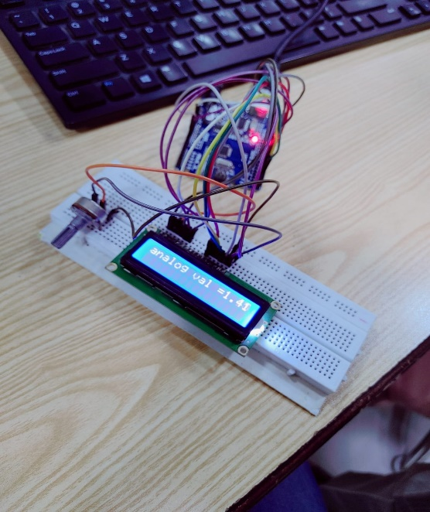Write a program to interface potentiometer with analog pin of Arduino Uno to read analog values and display it on LCD

#include <LiquidCrystal.h>

LiquidCrystal lcd(13, 12, 11, 10, 9, 8);

void setup() {

  lcd.begin(16, 2);}

void loop() {

  float voltage = analogRead(A0);

  voltage = ((voltage * 5) / 1023);

  lcd.setCursor(0, 0);

  lcd.print("analog val = ");

  lcd.setCursor(12, 0);

  lcd.print(voltage);

  delay(200);}

**Task 2**

Write a sketch to interface Arduino with the Temperature Sensor (LM35). The value of the Temperature should be displayed on the LCD

int tempPin = A0;

float temp;

#include <LiquidCrystal.h>

LiquidCrystal lcd(12, 11, 5, 4, 3, 2);

void setup() {

  lcd.begin(16, 2);  // Activating both Rows of LCD.

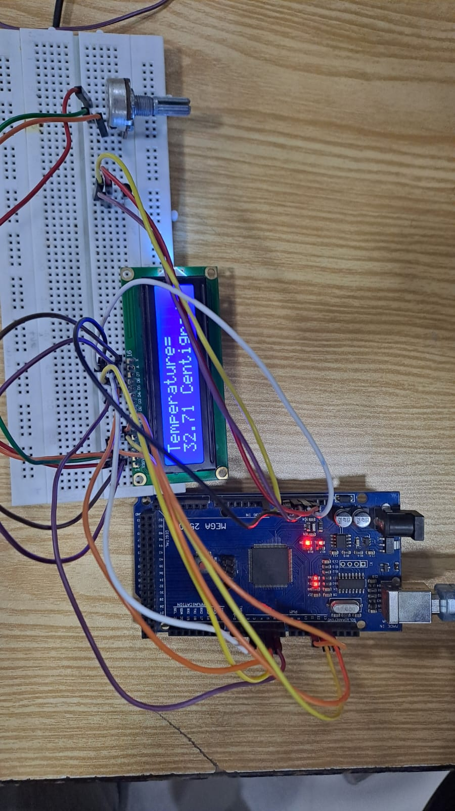  lcd.print("Temperature=");}

void loop() {

  temp = analogRead(tempPin);  // Reading the Temperature.

  temp = temp * 0.48828125;    // Conversion Factor.

  delay(1000);

  lcd.setCursor(0, 1);

  lcd.print(temp);

  lcd.print(" Centigrade");}